ASSIGNMENT NO.1: Introduction to Databases and SQL Environment
Student Name | Aayan Sayyed | Roll Number | 20963
Batch | SY. BSc Data Science | Topic | WB(Assignment-1)

Questions:

Q1) Write SQL commands to create a database named SchoolDB.
Query: CREATE DATABASE schooldb

CREATE TABLE student(

studentid int PRIMARY KEY,

studentname varchar(50) NOT NULL,

age int,

classname varchar(20),

city varchar(30)

);

Output:

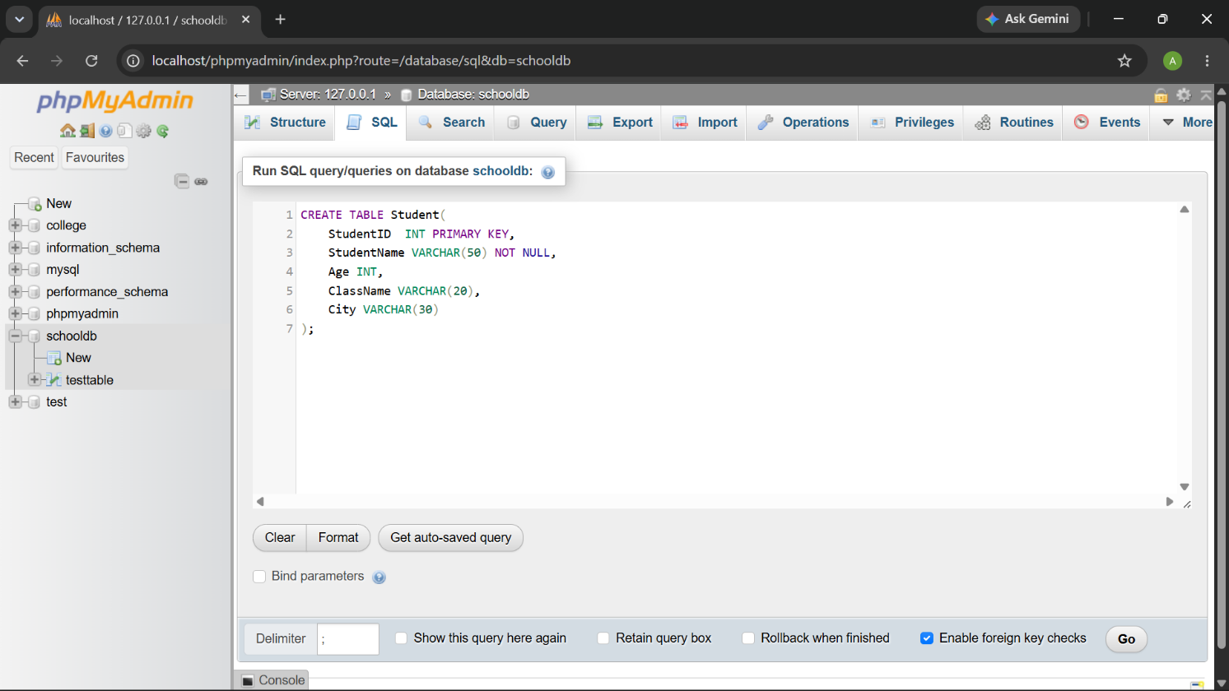

Q2) Create a table named Student with the following columns:
Query: CREATE TABLE student(

studentid int PRIMARY KEY,

studentname varchar(50) NOT NULL,

age int,

classname varchar(20),

city varchar(30)

);

Output:

Q3) Insert at least 10 records into the Student table.
Query: INSERT INTO student ( studentid, studentname, age, classname, city)
VALUES
(1, 'Arav Shah', 18, 'FYBSc IT', 'Mumbai'),
(2, 'Meera Joshi', 19, 'FYBCA', 'Pune'),
(3, 'Rohan Patil', 20, 'SYBSc IT', 'Nashik'),
(4, 'Sneha Desai', 18, 'FYBSc IT', 'Mumbai'),
(5, 'Amit Kumar', 21, 'TYBSc IT', 'Delhi'),
(6, 'Pooja Singh', 19, 'FYBCA', 'Pune'),
(7, 'Vikram Rao', 20, 'SYBSc IT', 'Bengaluru'),
(8, 'Neha Sharma', 18, 'FYBSc IT', 'Nashik'),
(9, 'Rahul Verma', 21, 'TYBSc IT', 'Mumbai'),
(10, 'Kavita Iyer', 19, 'SYBCA', 'Chennai');

SELECT * FROM Student;
Output:
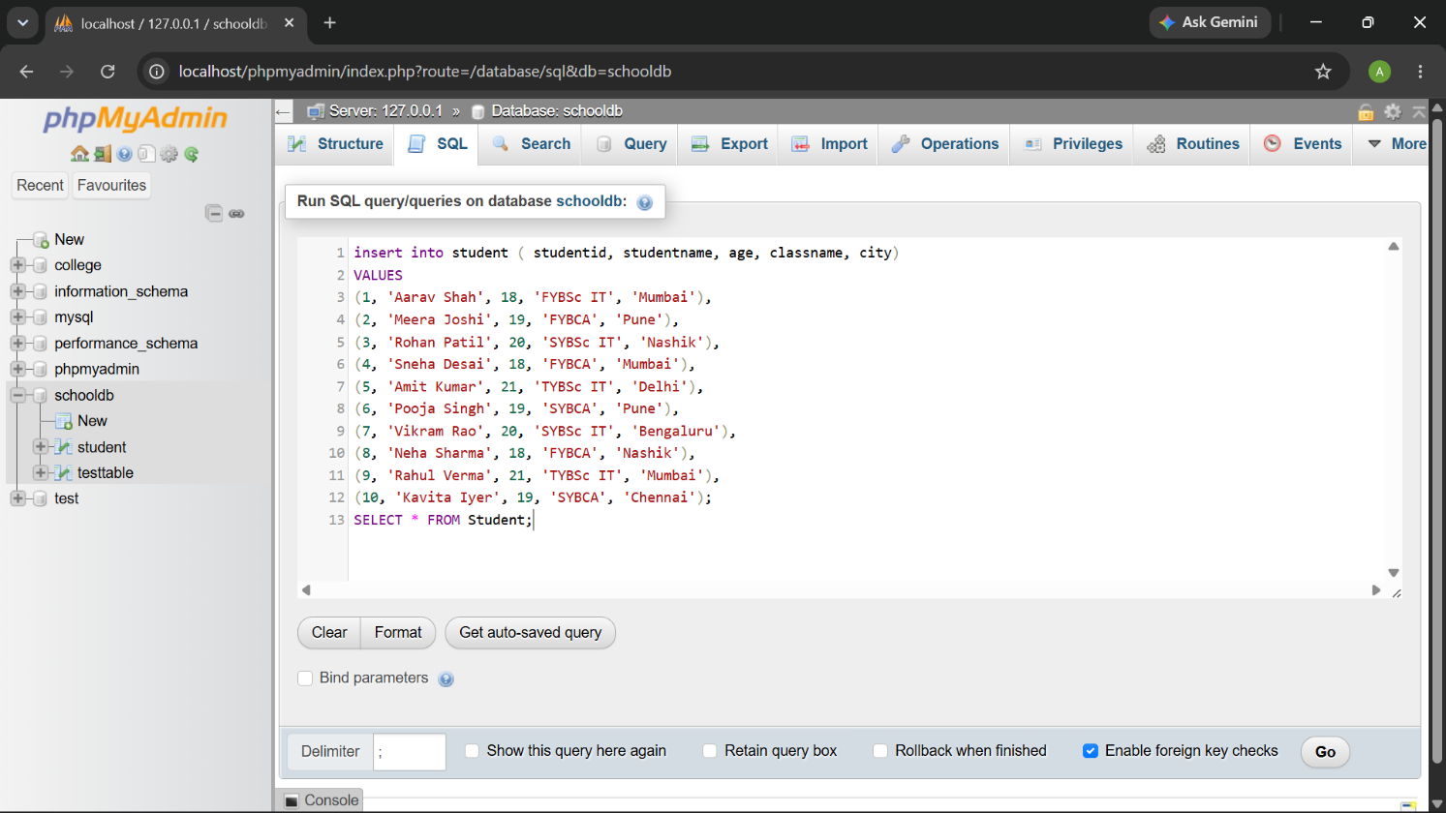

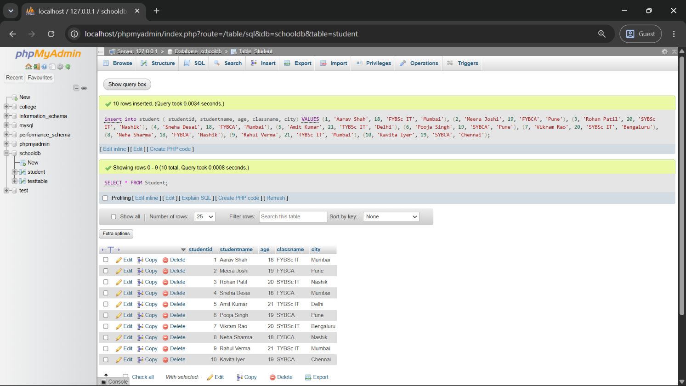

Q4) Create a table named Course with the following fields:

Query: CREATE TABLE course (

courseid INT PRIMARY KEY,

coursename VARCHAR(50) NOT NULL,

duration VARCHAR(20),

fees DECIMAL(10, 2)

);

INSERT INTO course (courseid, coursename, duration, fees) VALUES

(1, 'SQL Mastery', '2 Months', 4500.00),

(2, 'Python Basics', '3 Months', 6000.50),

(3, 'Java Pro', '4 Months', 8000.00),

(4, 'Web Dev Boot', '6 Months', 12000.75),

(5, 'Data Science', '6 Months', 15000.00);

SELECT * FROM course;
Output:
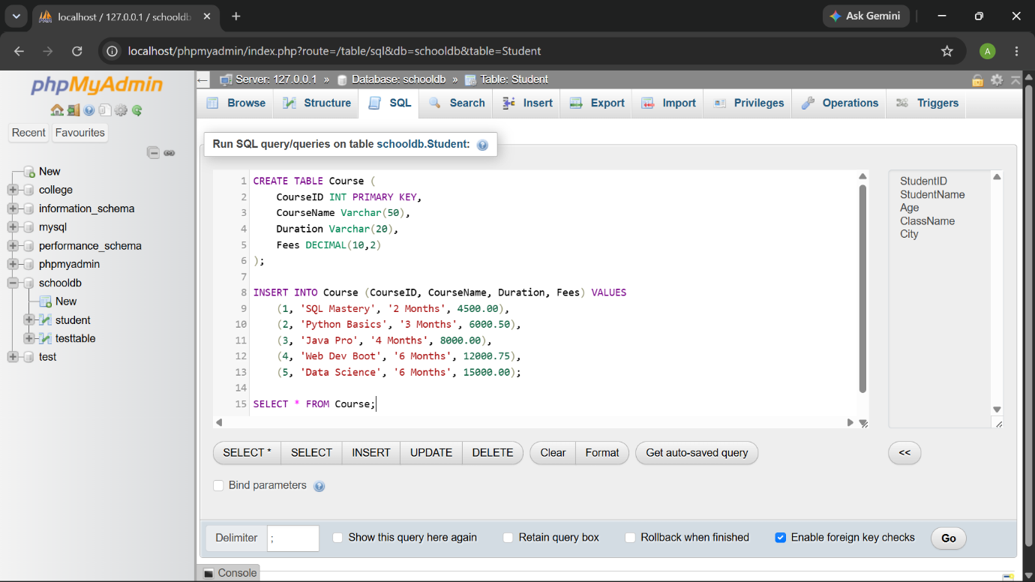

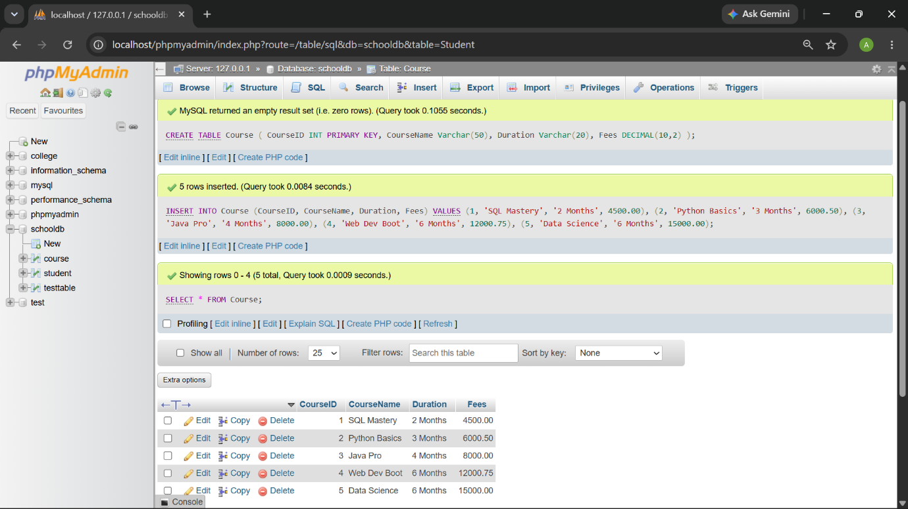

Q5) Write SQL queries to display only selected columns from the Student table.
Query: SELECT studentname, classname, city from student;
Output:
.
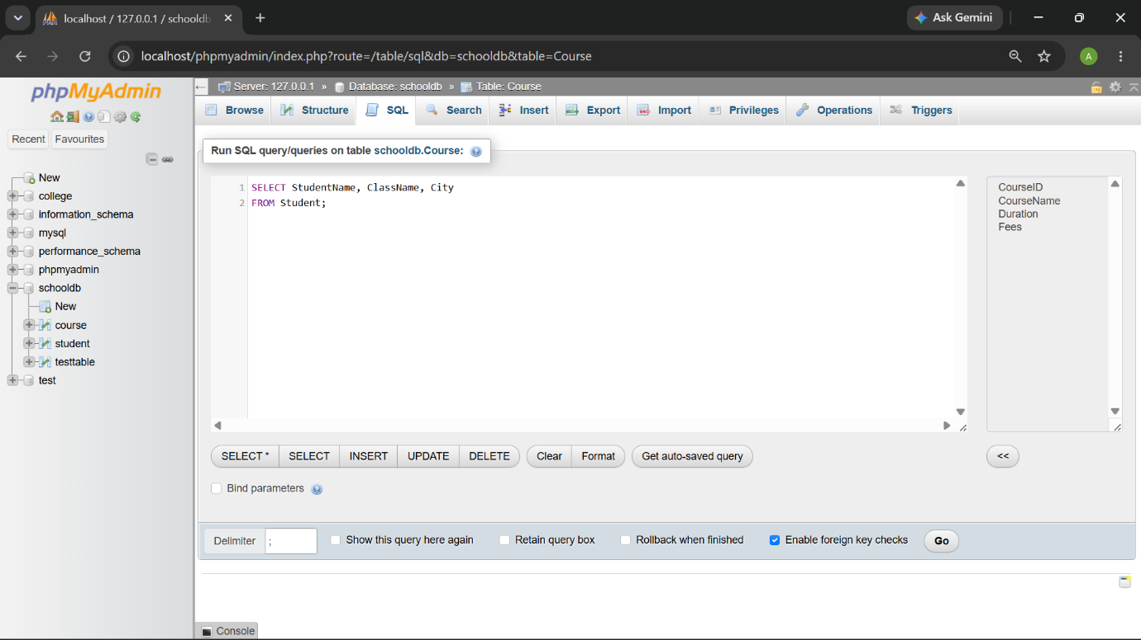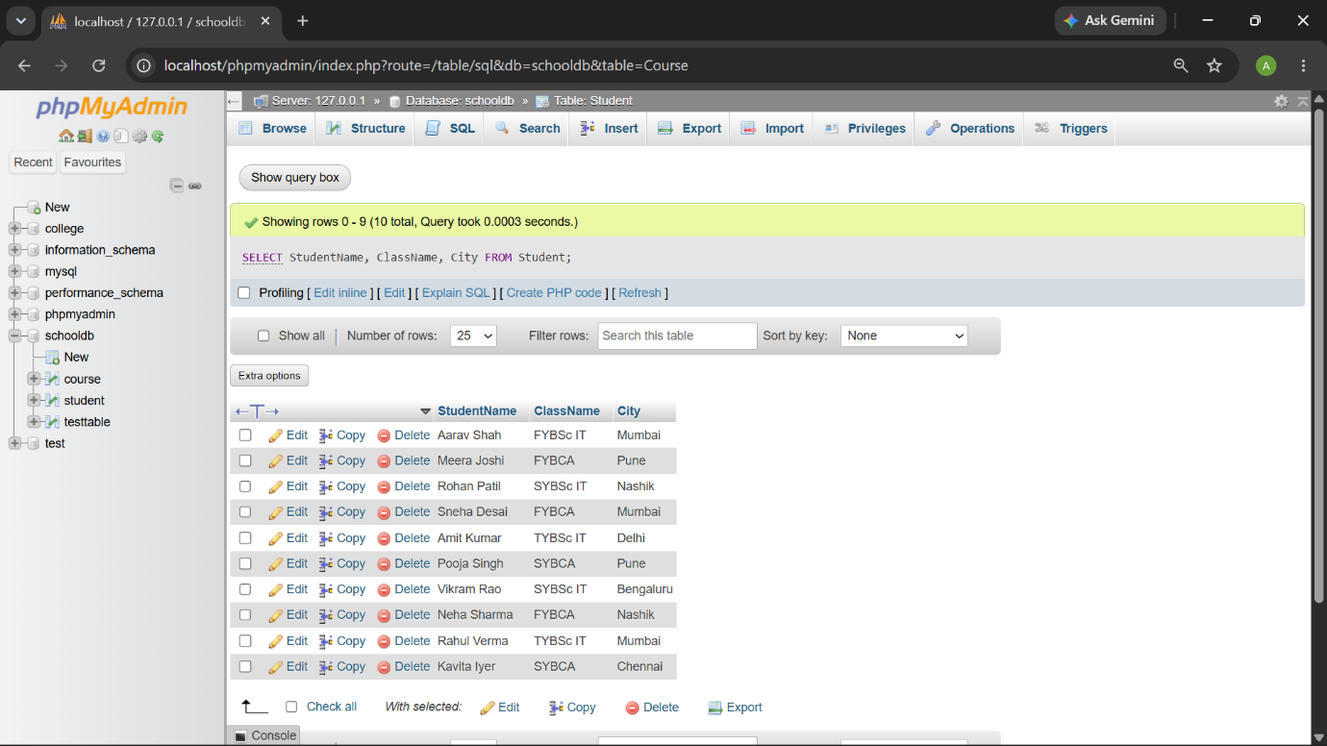

Q6) Write SQL commands to view the structure of the Student table.

Query: DESC student;
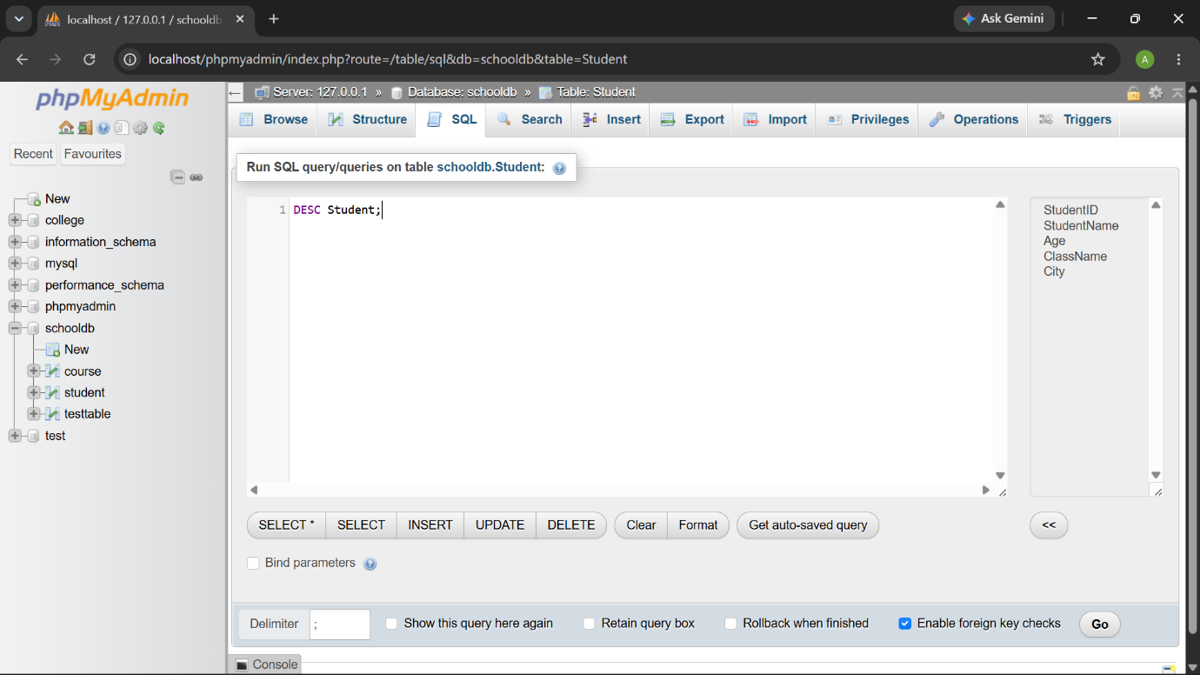

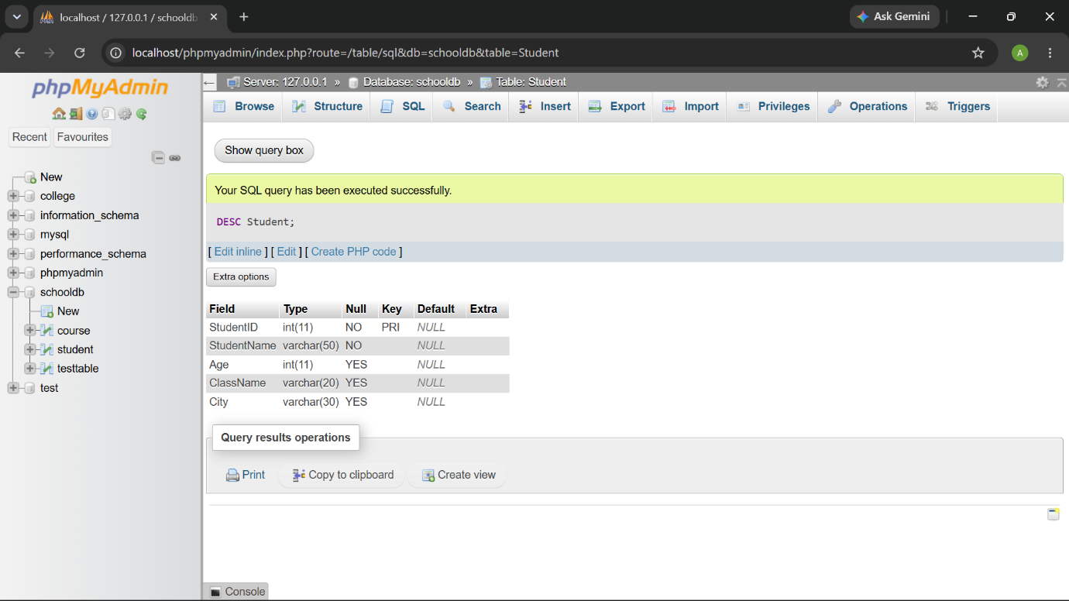

Q7) Prepare a CSV file named students.csv and import it into the Student table.

Query:

LOAD DATA INFILE "C:/Users/SDBI/Downloads/Students.csv"

INTO TABLE Student

FIELDS TERMINATED BY ','

ENCLOSED BY '"'

LINES TERMINATED BY '\n'

IGNORE 1 ROWS;

SELECT * FROM Student;

SELECT * FROM Student;
Output:
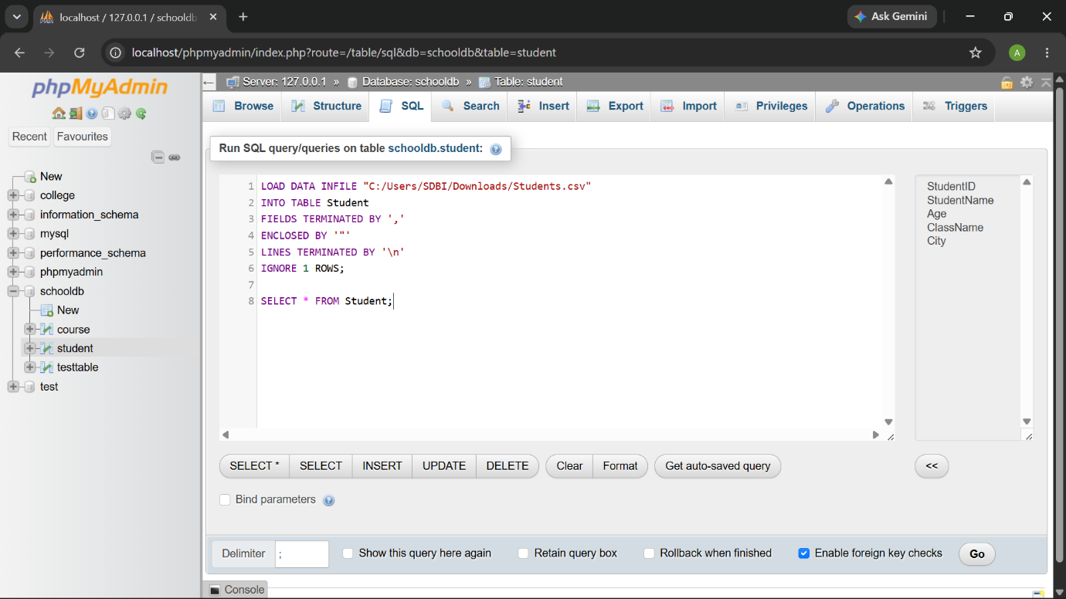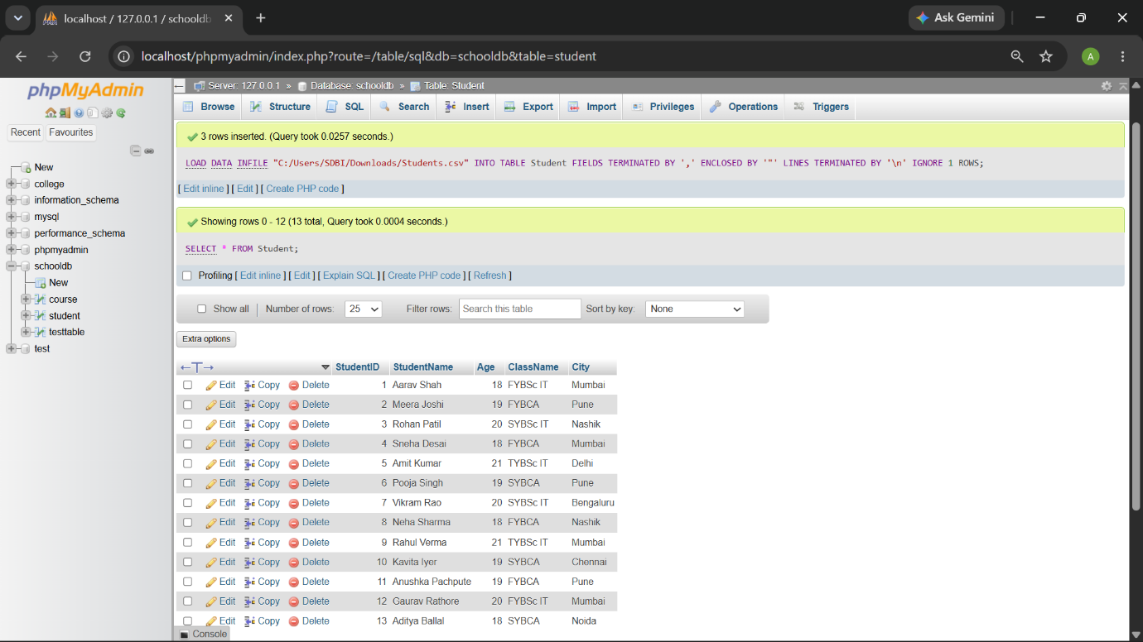

Q8) Create a database named EmployeeDB and a table named Employee.

Query: CREATE DATABASE EmployeeDB;

USE EmployeeDB;

CREATE TABLE Employee (

EmployeeID INT PRIMARY KEY,

EmployeeName VARCHAR(50),

Department VARCHAR(30),

Salary DECIMAL(10,2),

City VARCHAR(30)

);

INSERT INTO Employee VALUES

(101, 'John Doe', 'IT', 75000.00, 'New York'),

(102, 'Jane Smith', 'HR', 65000.00, 'Chicago'),

(103, 'Sam Brown', 'Finance', 83000.00, 'Boston'),

(104, 'Lisa Ray', 'IT', 78000.00, 'Seattle'),

(105, 'Mark Lee', 'Sales', 60000.00, 'Austin'),

(106, 'Anna Kim', 'Marketing', 68000.00, 'Denver'),

(107, 'Paul Dey', 'Finance', 91000.00, 'Miami'),

(108, 'Emma Watson', 'HR', 66000.00, 'Dallas');

SELECT * FROM Employee;
Output:
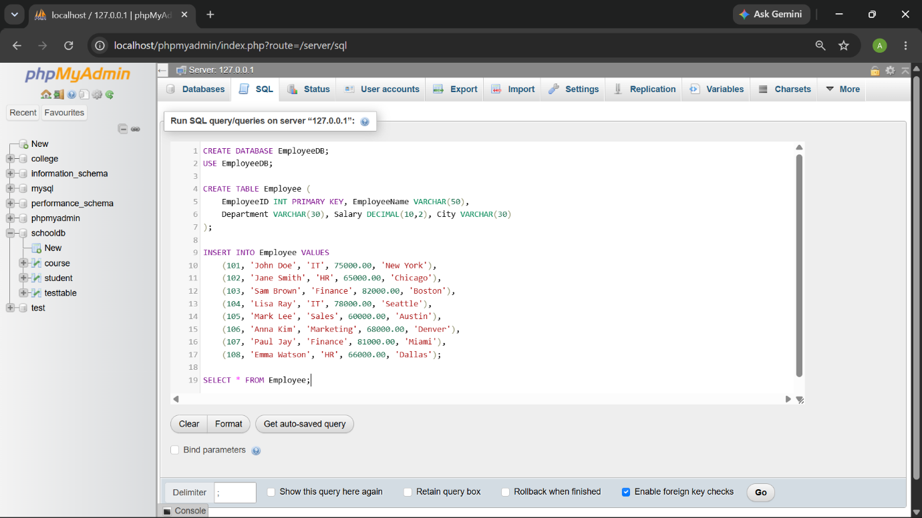

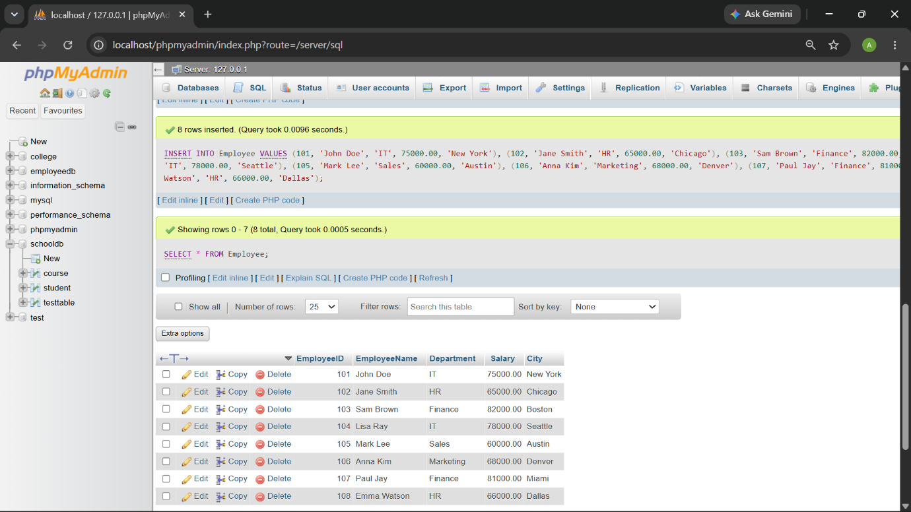

Q9) Write SQL queries to compare the difference between SELECT * and selecting specific columns.

Query:

SELECT StudentName, ClassName, City FROM Student;
Output:

Difference: The SELECT * command displays all available columns and rows from the table, whereas selecting specific columns restricts the output to only the requested fields (in this case, just the student's name and city)

Q10) Create a complete SQL script for a mini college database.
Query: CREATE DATABASE MiniCollegeDB;

USE MiniCollegeDB;

CREATE TABLE Student (SID INT PRIMARY KEY, SName VARCHAR(50));

CREATE TABLE Course (CID INT PRIMARY KEY, CName VARCHAR(50));

CREATE TABLE Faculty (FID INT PRIMARY KEY, FName VARCHAR(50));

INSERT INTO Student

VALUES (1,'Ali'),(2,'Ben'),(3,'Cam'),(4,'Dan'),(5,'Eve');

INSERT INTO Course

VALUES (10,'Math'),(11,'Sci'),(12,'Art'),(13,'Lit'),(14,'CS');

INSERT INTO Faculty

VALUES (100,'Dr.X'),(101,'Dr.Y'),(102,'Dr.Z'),(103,'Dr.A'),(104,'Dr.B');

SELECT * FROM Student; SELECT * FROM Course; SELECT * FROM Faculty;

DESC Student; DESC Course; DESC Faculty;
Output:

